**Assignment Day 4 Solutions**

**Question 1: Find out the mail servers of the following domain :**

|  |  |
| --- | --- |
| Domain | Mail servers |
| Ibm.com | [sowramac@in.ibm.com](mailto:sowramac@in.ibm.com) |
| Wipro.com | [info@wipro.com](mailto:info@wipro.com) |

**Question 2: Find the locations, where these email servers are hosted.**

|  |  |  |
| --- | --- | --- |
| Domain | Mail servers | Email servers hosted report |
| Ibm.com | [sowramac@in.ibm.com](mailto:sowramac@in.ibm.com) |  |
| Wipro.com | [info@wipro.com](mailto:info@wipro.com) |  |

**Question 3: Scan and find out port numbers open 203.163.246.23**

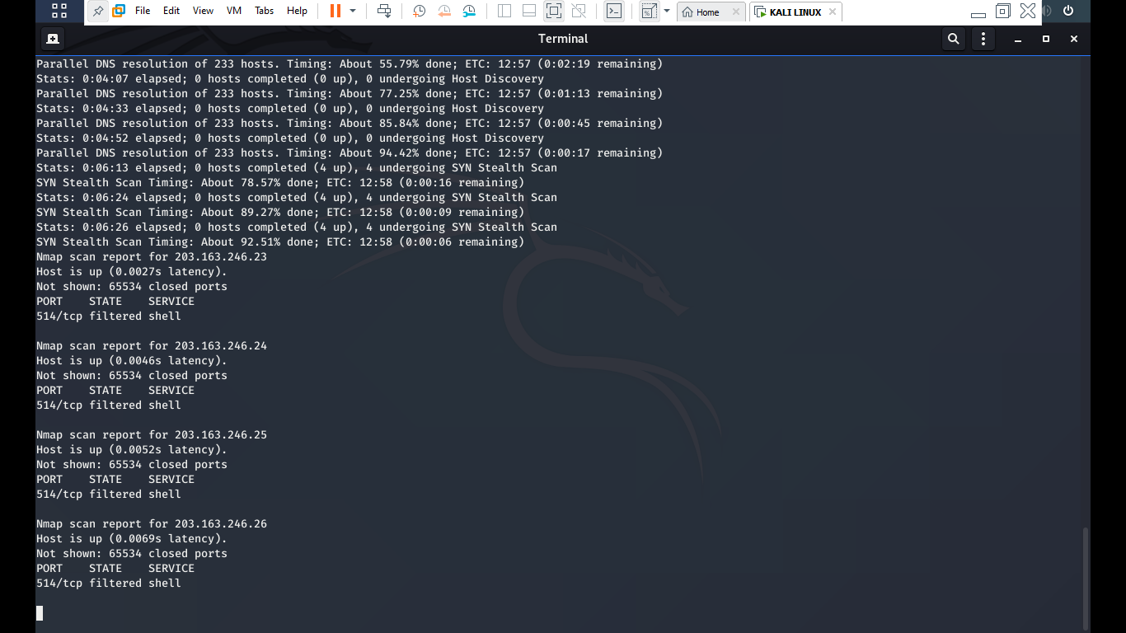

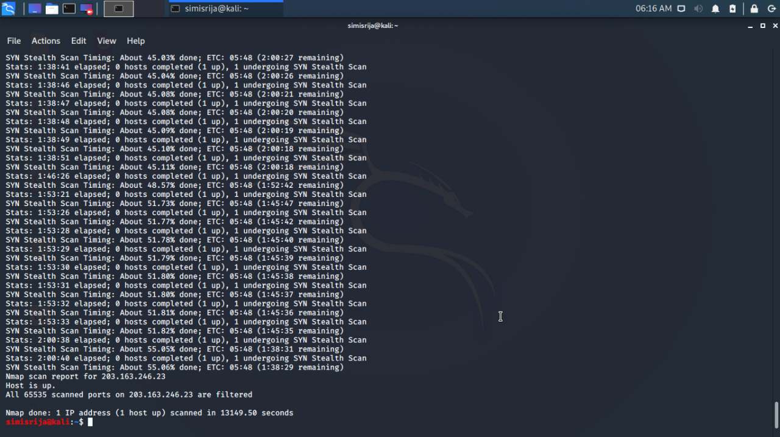

**Question 4: Install nessus in a VM and scan your laptop/desktop for CVE**

**MY IP :192.168.56.102**

**Scanning result:**

